INKING SURGICAL SAMPLES
Why should samples be inked at the clinic?
We highly recommend that all samples be inked at the clinic, especially larger samples!
Ink can and will be applied to samples at the laboratory, however, ink does not stick well to tissue that has already been submersed in formalin and a lot of ink will come off again during processing.
Tissue that has been inked at the clinic and THEN is placed into formalin with show up much better after processing.
Please take a look at the following example:
This is a large mammary tumour. One representative transverse section will need to be cut into multiple pieces in order to fit into multiple cassettes for processing (tan coloured histology cassettes in the background).
Cutting up of specimen is routinely done by laboratory scientists, not the pathologists.
The most important point is this: the pathologist cannot be sure that the edge of a sample under the microscope is indeed the surgical margin unless there is ink.
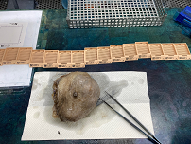

IVP provides surgical ink free of charge.
Drawing ink (pure or diluted with isopropyl alcohol 1:1) can be used as a cheap alternative.
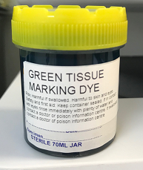We recommend to transfer the ink onto a flat washing-up sponge (from the supermarket) and a plastic container and soak the sponge with the ink. This can be re-hydrated with water (or alcohol if using drawing ink) if need be.
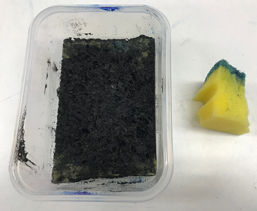
Washing-up sponge soaked in ink.
Imagine this is your surgical sample. The green bit on top is haired skin and the yellow is dermis & subcutaneous tissue.
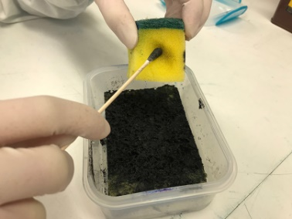
Using a cotton swab or just gloved fingers apply the ink to the surgical margins.
In this case the surgical margin is everything yellow.
Haired skin (dark green in this fictitious sample) does not need to be inked, it’s always obvious under the microscope.
Please note though that THERE IS NO SUCH THING AS TOO MUCH INK!!!!

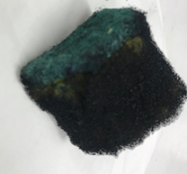
Once you are satisfied that the entire sample has been inked leave it to dry for around 5 minutes and THEN place in formalin as per usual.
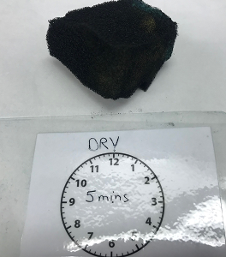
Leave to dry for approx.5 minutes…then place in formalin.
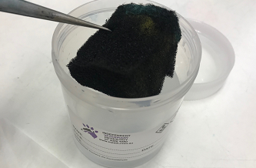
Place sample in formalin as per usual.
Please note that the formalin may take on the colour of the ink – that’s fine.

