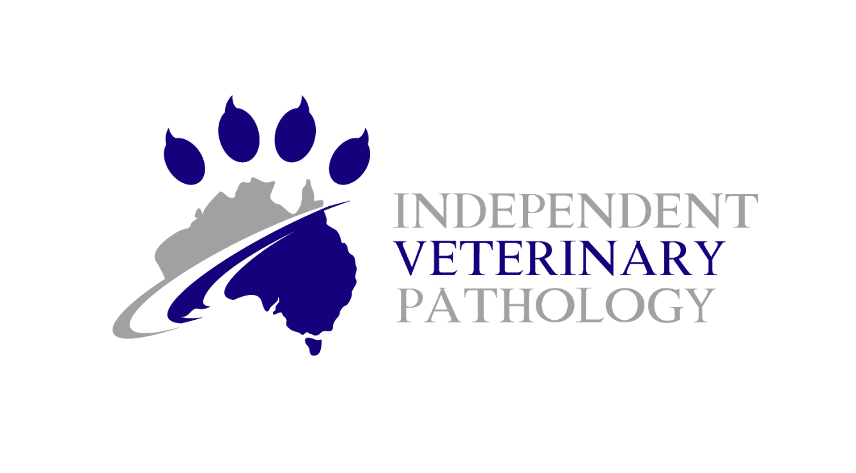
Independent Veterinary Pathology Post-Mortem Tips
For submission of post-mortem (or necropsy) samples, it is important to provide a whole picture of the case to get the best possible interpretation of your samples. This includes animal signalment, clinical history (emailed if long/complicated), gross findings from the post mortem (see our ‘gross examination’ form on our website) as well as photographs of any gross changes.
Please see the post-mortem gross examination form. Feel free to call us at IVP for any advice or questions before, during or after your in-clinic necropsy on (07) 3088 4080, or on our individual mobile numbers found in our report signature.
For each lesion observed during your necropsy, please include as many of the following descriptors as you can:
- Location
- Colour
- Size (measured)
- Shape
- Consistency and texture
- Number or extent (% of the organ affected)
- Content – material/volume
- Photographs can easily be sent to our photo email address at photo@ivpath.com.au

It is helpful to be familiar with common, non-lesional post-mortem changes, particularly if the body has been frozen or stored prior to necropsy:
- Hypostatic congestion (livor mortis): Blood pools by gravity on the down-side of the animal within the skin and organs
- Haemoglobin imbibition: Dull-red discoloration of tissue due to lysis of red blood cells
- Bile imbibition: Yellow to green discoloration of tissue adjacent to the gallbladder
- Pseudomelanosis: Red-tan to grey or nearly black discoloration of tissue due to autolysis
- Putrefaction: Severe softening and accumulation of gas in the tissues due to autolysis

*For potential reportable disease cases please contact your local biosecurity laboratory, which for Queensland is Biosecurity Sciences Laboratory: The Biosecurity Sciences Laboratory | Business Queensland.

Independent Veterinary Pathology Post-Mortem Tips

Helpful tips:
- Fill out a submission form with a complete, detailed history including differential diagnoses and clinical concerns regarding the patient's disease
- Also include photos and blood tests/other laboratory results if possible.
- Use 10% neutral buffered formalin and ensure a 10:1 formalin to tissue ratio. We supply buckets up to 4 litres if required!
- Maximum 1cm in thickness where possible – this ensures fast fixation and less autolysis (rotting) of the tissue.
- For animals where poisoning is a suspected cause of death, take some liver samples and stomach contents and freeze in separate labelled jars (e.g. urine collection jar) in case future additional testing is recommended.
- It can be helpful to include a list of tissues sampled, particularly if a small piece is taken or the organ is small (such as thyroid glands) as these can sometimes get lost amongst larger pieces if they are all in the same bucket or pot.
- Freezing of organs or whole animals is always an option if you don’t have time for a necropsy in the short term (hours or the next day), or if the owner needs more time to decide whether to go ahead with necropsy or histology. If freezing, it is important that de-frosting is controlled ie. Defrost a whole body in the fridge, not at room temperature. If tissue samples were frozen, these can be placed in formalin then allowed to defrost in the fridge.
- PetMD provides a useful article for pet owners considering necropsy: How To Know If Your Pet Needs A Necropsy (And What's A Necropsy Anyway?) | PetMD

Pocket pets and birds:
- For birds, wet down with water and refrigerate immediately to minimise autolysis (feathers keep in the body heat and speed up tissue decomposition).
- Did you know that we can perform necropsies at the lab on any animal 1kg or less? These can be submitted fresh (preferable) if they can be at the lab in 1-2 days, or another option is to make a midline incision and submerse the entire body in formalin (you will likely need a 4L bucket for this).

